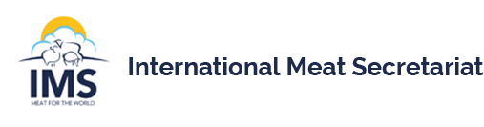
IMS MARKETING WORKSHOP

The 12th IMS Marketing Workshop is being hosted by Bord Bia-The Irish Food Board
in Dublin, Ireland, from 4-6 October 2023.

Since 1997 the Marketing Workshops, hosted on 4 Continents, have brought together the international meat marketing community to share common experiences of marketing and communications to domestic and international audiences on a wide range of topics. Historically topics have included advertising and communications campaigns, evaluation, human health, sustainability, quality schemes and crisis management. Always topical and relevant.

The format is simple. Delegates are encouraged to deliver short presentations, within topic areas, followed by informed discussion. External, relevant, quality presenters will be brought in to add other perspectives, and lead discussion, on selected issues/topics.
Draft programme outline:

WEDNESDAY 4TH OCTOBER
18.00 Assemble at Herbert Park Hotel for transfer to Guinness Storehouse

THURSDAY 5TH OCTOBER Bord Bia Global Hub
08.30 Registration and Introductory Welcome
Country Presentations
SESSION ONE, Marketing in a Recession
Lunch
SESSION TWO, Barriers to Meat Consumption
17.15 Close Day 1
19.00 Drinks reception prior to Workshop Dinner at Bord Bia Global Hub

FRIDAY 6TH OCTOBER Bord Bia Global Hub
09.00 Country Presentations
SESSION THREE, Development and Potential of Meat Consumption
SUMMING UP
13.00 CLOSE and Buffet Lunch

14.00 Optional sustainability themed farm visit

Drop off to Dublin airport will be facilitated or a return to Dublin city for those staying on in Dublin.

We have arranged a fixed rate at the nearby Herbert Park Hotel & Park Residence for the event. This will be valid from 04/10 – 06/10 at a rate of €205 B&B single occupancy/€220 B&B double occupancy.

Group Reservations
Herbert Park Hotel and Park Residence
Ballsbridge, Dublin 4
Tel: +353 1 667 2200
Email: reservations@herbertparkhotel.ie
Web: www.herbertparkhotel.ie

Quote Bord Bia IMS Seminar to avail of this rate, which will be available until 15th June.

A delegate fee will be charged in order to cover costs for transport and events in Bord Bia and t eh Guinness Storehouse at the rate of €600 for IMS member and €700 for non-IMS members.
Book here

The workshop dates have been agreed as they are immediately before ANUGA,
in Cologne, hopefully helping with travel costs for those attending both events.

Full details will be provided in the coming weeks including details of external speakers, delegate fees and accommodation options. In the meantime, should you require any more information please contact: mark.zieg@bordbia.ie

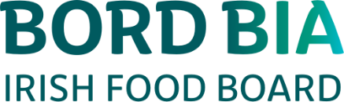

Mark Zieg Peter Haydon
Beef Sector Manager IMS Marketing Committee Chair

